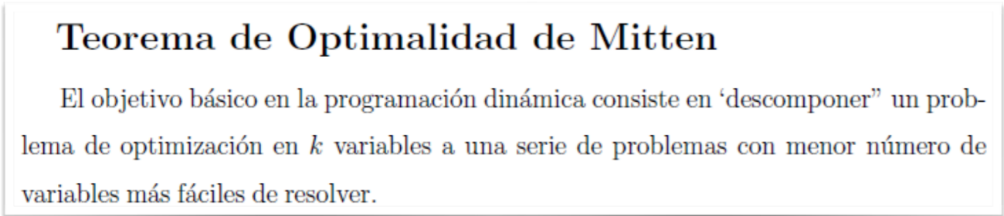**Pseudocode PD, Backtracking, Branch and Bound**

Levenstein(O(m*n))

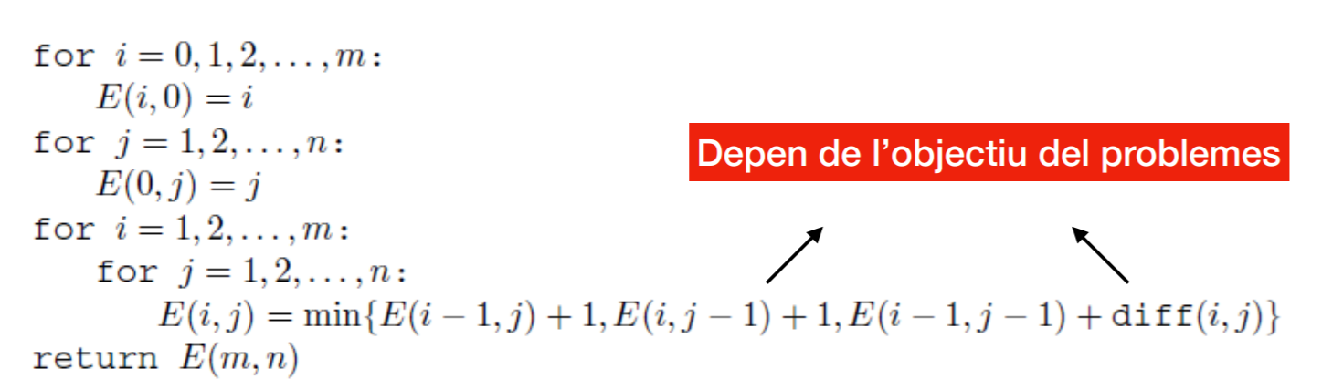

Floyd-Washall (O(V**3))

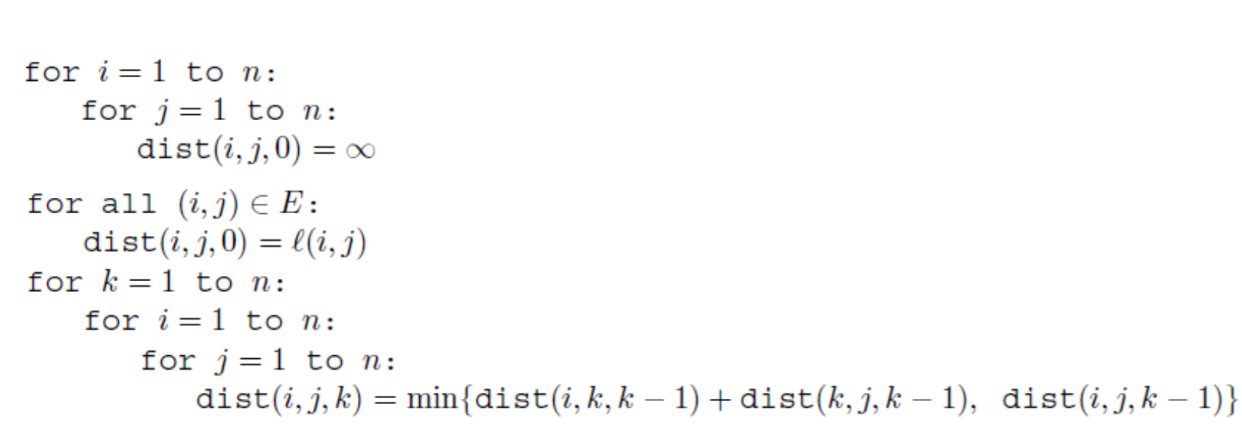

Knapsack PD (O(n*W))  
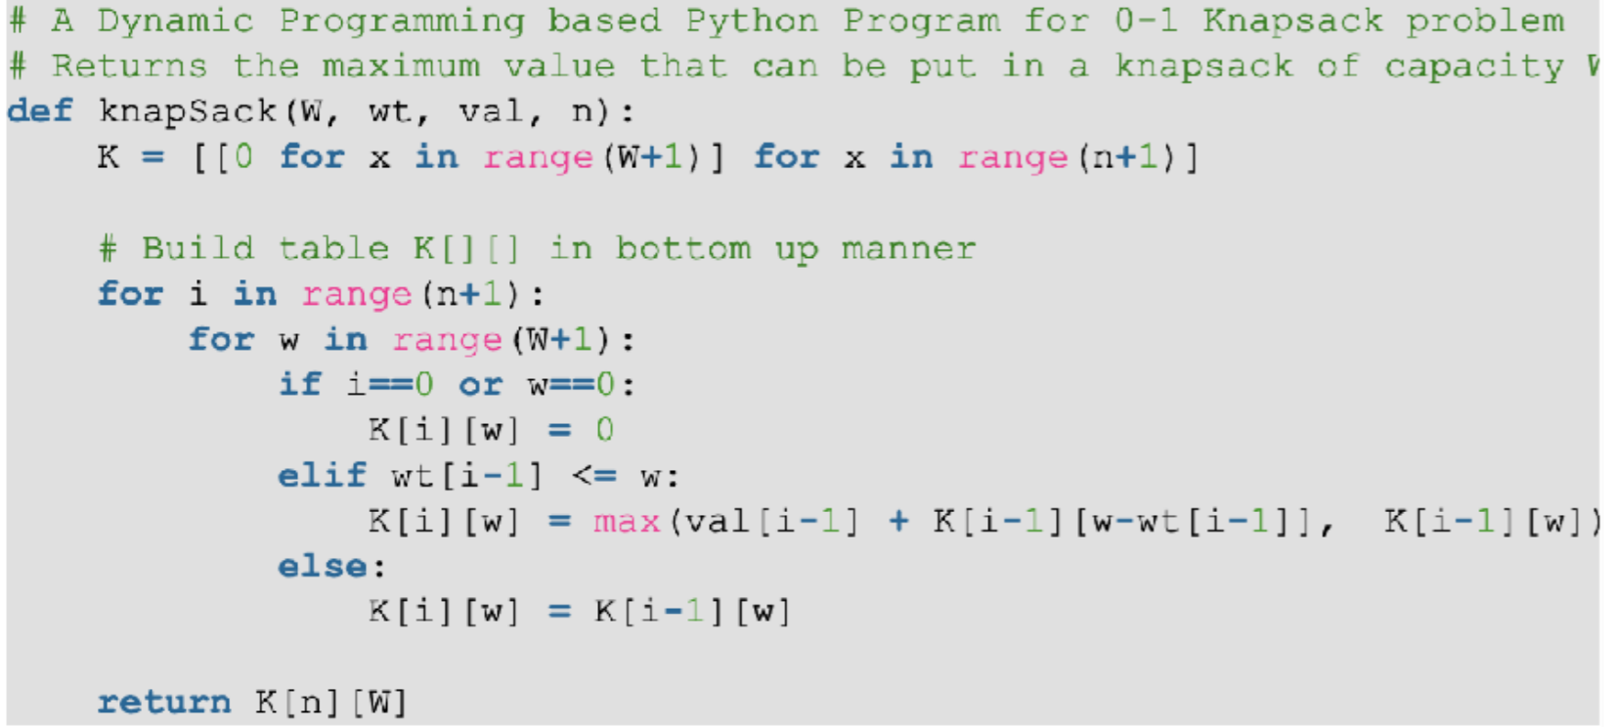

TSP PD(O(n**2*2**n))

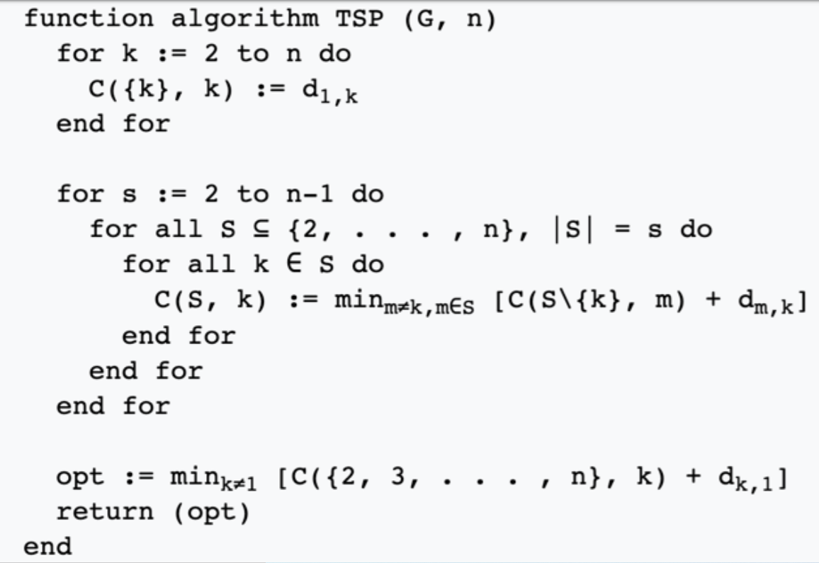

Backtracking(Global Strategy)

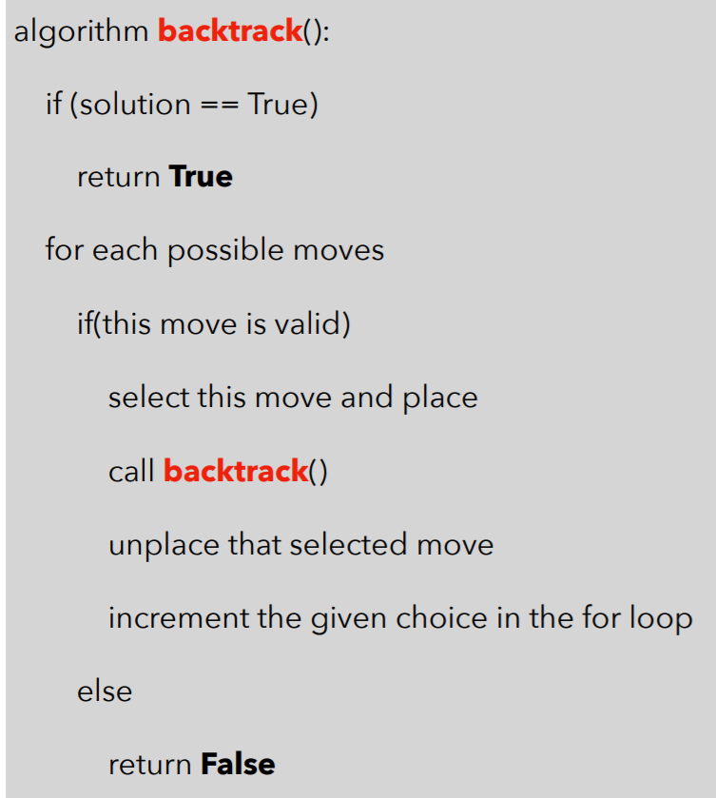

Backtracking Grafos(Strategy)

